**Sequence Diagram: Communities Page**

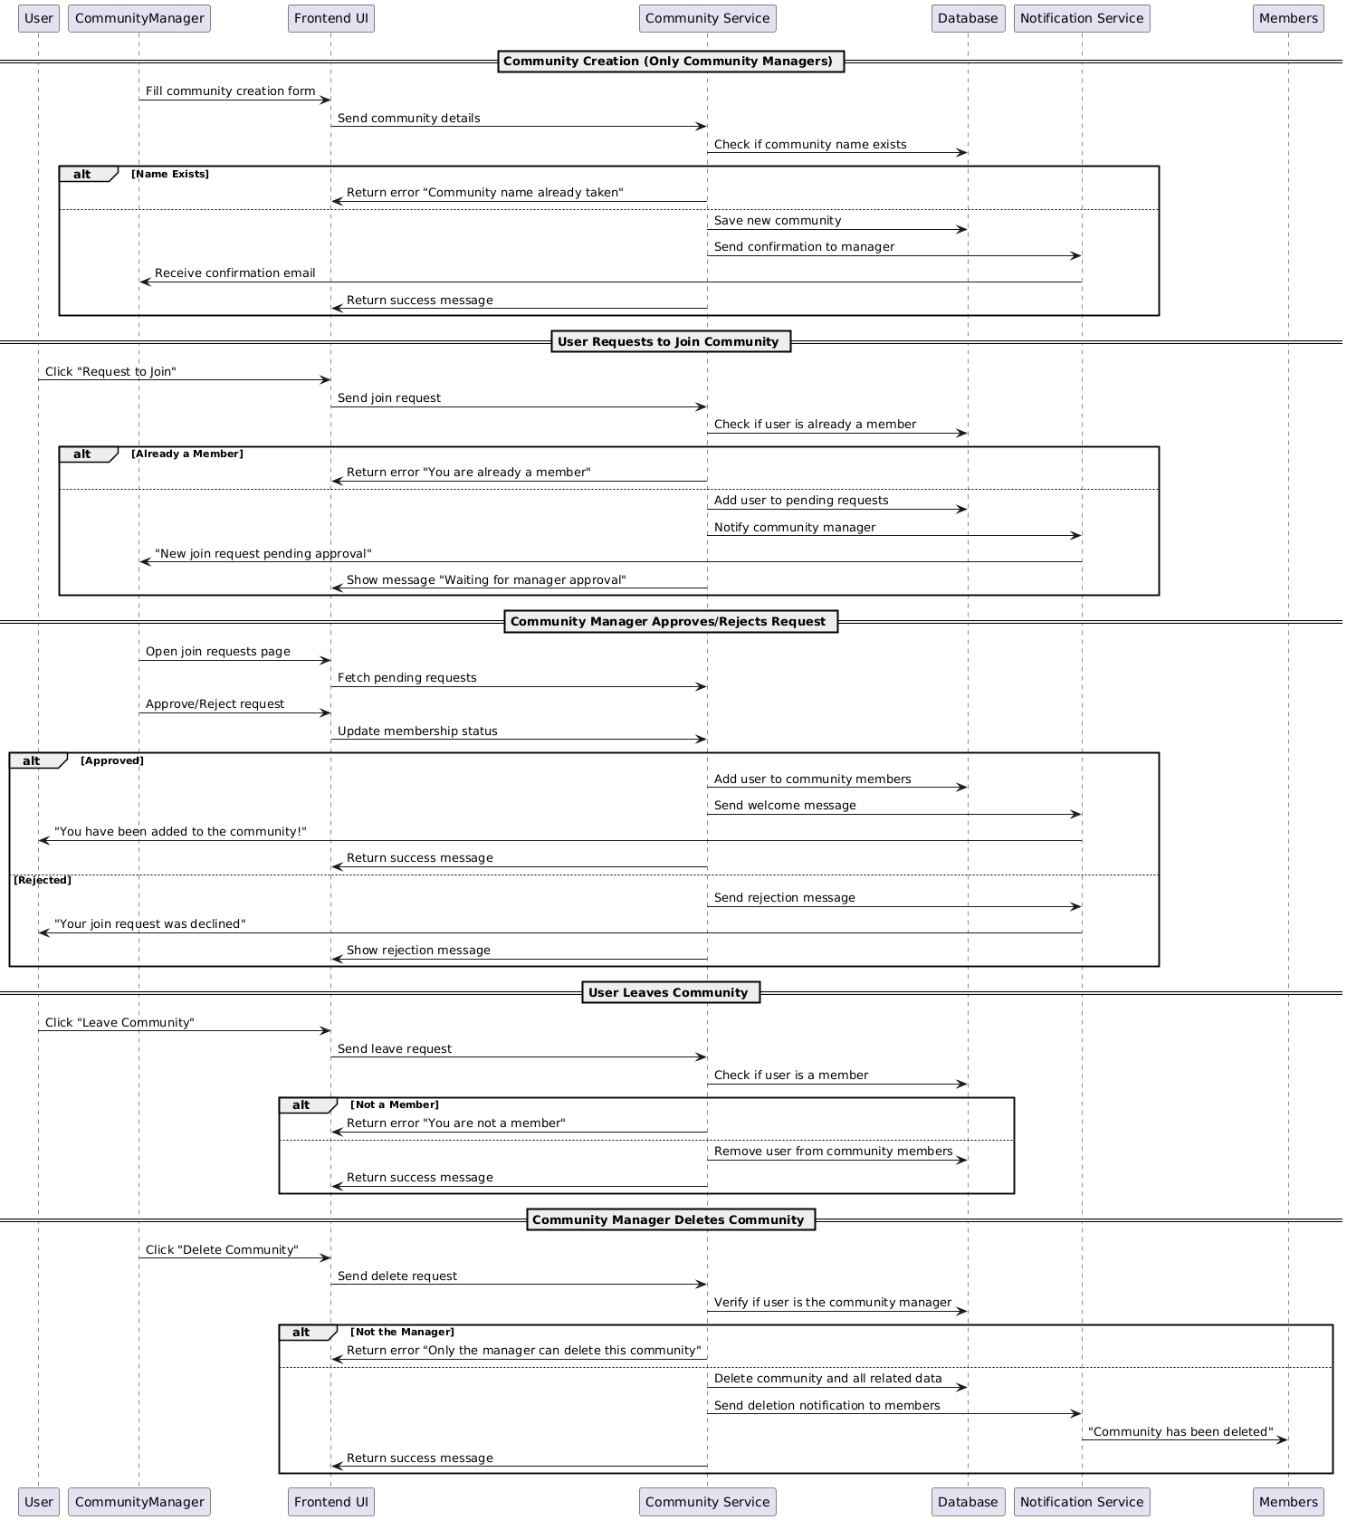

**Database:**

**Functional Requirements (FRs)**

**Community Creation (Only Community Managers)**

* **FR1:** The system shall allow Community Managers to create a new community by providing the required details (e.g., name, description).
* **FR2:** The system shall validate that the community name is unique before allowing the creation of a community.

**User Membership in Communities**

* **FR3:** Users shall be able to join a community by clicking the "Join Community" button.
* **FR4:** The system shall validate that the user is not already a member of the community.
* **FR5:** If the user is already a member, the system shall display an error message: "You are already a member."
* **FR6:** Upon successful joining, the system shall add the user to the community and send a welcome message.

**User Leaving Community**

* **FR7:** Users shall be able to leave a community by clicking the "Leave Community" button.
* **FR8:** The system shall remove the user from the community members list upon confirmation.
* **FR9:** The system shall display a success message upon successfully leaving the community.

**Community Deletion (Only Community Managers)**

* **FR10:** Community managers shall be able to delete a community they manage.
* **FR11:** The system shall validate that the user requesting the deletion is the Community Manager.
* **FR12:** If the user is not the community manager, the system shall display an error message: "Only the manager can delete this community."
* **FR13:** Upon deletion, the system shall remove all community data, including member records and posts, from the database.

**Non-Functional Requirements (NFRs)**

**Performance & Reliability**

* **NFR1:** The system shall process the community creation request within 3 seconds to provide a smooth user experience.
* **NFR2:** The system shall process user join/leave requests within 2 seconds for a fast response.

**Usability**

* **NFR3:** The user interface shall be simple and intuitive for both Community Managers and users.
* **NFR4:** The system shall display clear error messages for users attempting actions they are not authorized for (e.g., trying to delete a community without manager rights).
* **NFR5:** The community creation and management interface shall be responsive and work well on both desktop and mobile devices.

**Security**

* **NFR9:** Only authenticated users with proper permissions (Community Managers) shall be allowed to create or delete communities.
* **NFR10:** The system shall ensure that users can only join communities they are not already a part of and cannot perform unauthorized actions like deleting communities they don't manage.